Social Studies 9 Course Outline

My teacher’s name is: _________________________________
Their email address is: _________________________________
Our classroom is: _____________________________________
Our classroom webpage is: _____________________________

Course Content

Area of Learning: SOCIAL STUDIES — 1750 – 1919
Social Studies 9 students will specifically be studying:
• The Age of Enlightenment and the French Revolution
• The Industrial Revolution
• Nationalism in Europe and North America in the 19th century
• Canada’s Geographic Regions
• British North America to Confederation
• The emergence of Western Canada: migration, Northwest Rebellion, British Columbia
• The Laurier Era
• Canada’s participation in World War
• Current Events

Core Competencies

The core competencies along with literacy and numeracy foundations and essential content and concepts are at the centre of the redesign of curriculum and assessment. Core competencies are sets of intellectual, personal, and social and emotional proficiencies that all students need to develop in order to engage in deep learning.
- Communication -The communication competency encompasses the set of abilities that students use to impart and exchange information, experiences and ideas, to explore the world around them, and to understand and effectively engage in the use of digital media.

- Thinking - The thinking competency encompasses the knowledge, skills and processes we associate with intellectual development. It is through their competency as thinkers that students take subject-specific concepts and content and transform them into a new understanding. Thinking competence includes specific thinking skills as well as habits of mind, and metacognitive awareness.

- Personal and Social - Personal and social competency is the set of abilities that relate to students' identity in the world, both as individuals and as members of their community and society. Personal and social competency encompasses the abilities students need to thrive as individuals, to understand and care about themselves and others, and to find and achieve their purposes in the world.

Big Ideas:

- Emerging ideas and ideologies profoundly influence societies and events.
- The physical environment influences the nature of political, social, and economic change.
- Disparities in power alter the balance of relationships between individuals and between societies.
- Collective identity is constructed and can change over time.

- Students are expected to know the following Content:

- Political, social, economic, and technological revolutions
- Imperialism and colonialism, and their continuing effects on indigenous peoples in Canada and around the world
- Global demographic shifts, including patterns of migration and population growth
- Nationalism and the development of modern nation-states, including Canada
- Local, regional, and global conflicts
- Discriminatory policies and injustices in Canada and the world, such as the Head Tax, the Komagata Maru incident, residential schools, and World War I

- Students are expected to be able to do the following Core Competencies:

- Use Social Studies inquiry processes and skills to ask questions; gather, interpret, and analyze ideas; and communicate findings and decisions
- Assess the significance of people, places, events, or developments, and compare varying perspectives on their historical significance at particular times and places, and from group to group (significance)
- Assess the justification for competing historical accounts after investigating points of contention, reliability of sources, and adequacy
of evidence (evidence)
- Compare and contrast continuities and changes for different groups at the same time period (continuity and change)
- Assess how prevailing conditions and the actions of individuals or groups affect events, decisions, or developments (cause and consequence)
- Explain and infer different perspectives on past or present people, places, issues, or events by considering prevailing norms, values, worldviews, and beliefs (perspective)
- Recognize implicit and explicit ethical judgments in a variety of sources (ethical judgment)
- Make reasoned ethical judgments about actions in the past and
present, and determine appropriate ways to remember and respond
(ethical judgment)

We will be working to develop knowledge and skills relating to these core competencies (from Dr. Peter Sexias, UBC, book titled The Big 6):
Historical Significance | How do we decide what is important to learn about the past?
Evidence | How do we know what we know about the past?
Continuity and Change | How can we make sense of the complex flows of history?
Cause and Consequence | Why do events happen, and what are their impact?
Historical Perspective | How can we better understand the people of the past?
The Ethical Dimension | Are moral and ethical considerations informed by historical, geographical, and social context?

Learning In Depth Inquiry:
At the beginning of the semester, each student will be assigned a topic of inquiry. This will be your “LiD” project topic (Learning in Depth). LiD is a semester long portfolio project that allows you to build off of the things we learn in class and dive deeper into a specific topic in order to become an expert. The highlight of the LiD project is the semester end presentations where you get to showcase your knowledge to the rest of the class.

Supplies:

You will need to bring pens/pencils, a binder and lined paper to every class. On occasion you may need scissors, glue, pencil crayons, and rulers, but you will be given notice in advance so it is not necessary to bring these extra supplies to every class. Please come to class prepared.

Classroom Expectations:

1. No use of cell phones/iPods etc. in class for anything other than listening to music during student work time with headphones only. They are not to be seen at all during teacher instruction time. If this privilege is abused then the policy will change to no cell phones/iPods etc. at all.
2. No gum, food or drink other than water. Ask for permission due to special circumstances.
3. This is an academic course. I expect you to work quietly, ask questions if you don’t understand and respect the feelings and rights of others.
4. If you miss a quiz/test you, I will need verification from your parent/coach in order to write a make-up
5. Class starts at the bell. If you come and the door is closed and locked you are considered late – you will be allowed in but marked late.
6. All homework, assignments and tests should be completed and submitted on time.
7. If you are unhappy with a mark, I will give you another chance (1-2 times in the year).
8. You may be recommended for the final exam instead of a final project (you do not need to write it if you have a mark higher than 71.5% and less than 10 absences in the course).
Marks are available online on Student and Parent Connect. The password is your student number. Evaluation: Terms 1 and 2 are each worth 40% of your overall mark:
- Tests 30%
- Quizzes 20%
- Projects/Assignments 40%
- Participation 10%
Assignments & Projects
It is your responsibility to complete and submit assignments and projects on time – all the time! Major projects and/or assignments will be accompanied by an outline and marking rubric. If absent or late to class, it is the student’s responsibility to find out what was missed and submit the assignment/project as soon as possible. Assignments are regularly posted on the teacher’s website and student connect. Late projects and assignments should be submitted before the end of the assigned Term.

Tests & Quizzes
It is your responsibility to prepare for and complete all tests and quizzes. If you know that you will be absent for a test, please notify me in person, by note, or email as soon as possible to make alternate arrangements. Contact me to arrange for a make-up test as soon as possible.

Punctuality & Attendance & Class Behavior
Students are expected to attend all classes all of the time – on time! Students will be expected to behave in a courteous and respectful fashion. Students arriving late are to enter class as quickly and quietly as possible so as not to disrupt the learning environment for other students. Lates and absences are to be accompanied with a note from and administrator and/or parent/guardian. Excessive tardiness, unexcused absences or unacceptable class behavior will be referred to Counsellor, Administrator, and/or Parents/Guardians for possible discipline.

Assessment
You will be assessed continually throughout each unit of study. We will have check-for-understanding assignments as well as more summative tasks (tests, projects, presentations, written responses, etc.). At the end of the semester, you will meet with your teacher to discuss where you are at in terms of developing your core competencies. You will receive a percentage on your report card and a rubric explaining where you are in your skills development. You will also have a meeting with your teacher at the end of the semester to discuss your progress.

Specific Area of Learning: SOCIAL STUDIES — 1750 – 1919
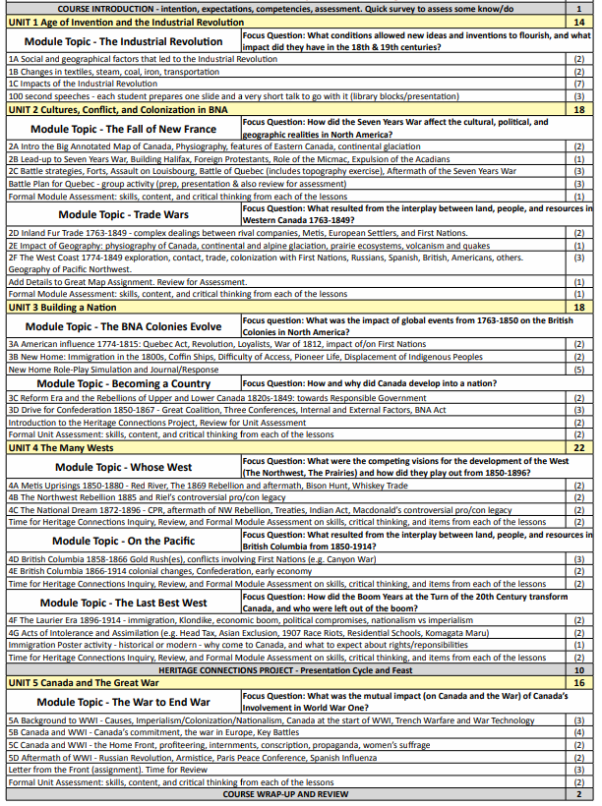
(Chart adapted from G. Thielmann for the Pacific Slope Consortium 2016 pacificslope.ca)

