Social Studies 10 Course Outline

My teacher’s name is: _________________________________
Their email address is: _________________________________
Our classroom is: _____________________________________
Our classroom webpage is: _____________________________

Course Content

Area of Learning: SOCIAL STUDIES — Canada and the World: 1919 to the Present

- Big Ideas:
- Global and regional conflicts have been a powerful force in shaping our contemporary world and identities.
- The development of political institutions is influenced by economic, social, ideological, and geographic factors.
- Worldviews lead to different perspectives and ideas about developments in Canadian society.
- Historical and contemporary injustices challenge the narrative and identity of Canada as an inclusive, multicultural society.

- Students are expected to know the following Content:
- Development, structure, and function of Canadian and other political institutions, including First Peoples governance
- Political and economic ideologies and the development of public policy
- Changing conceptions of identity in Canada
- Canadian autonomy
- Domestic conflict and co-operation
- Discriminatory policies and injustices in Canada and the world, such as the Head Tax, the Komagata Maru incident, residential schools, and internments
- International conflicts and co-operation
- Human–environment interaction
- Economic development and Canada’s role in a global economy
- Truth and reconciliation in Canada

- Students are expected to be able to do the following Core Competencies:
- Make reasoned ethical judgments about actions in the past and present, and determine appropriate ways to remember and respond (ethical judgment)
- Use Social Studies inquiry processes and skills to ask questions; gather, interpret, and analyze ideas; and communicate findings and decisions
- Assess the significance of people, places, events, or developments, and compare varying perspectives on their significance at particular times and places, and from group to group (significance)
Assess the justification for competing accounts after investigating points of contention, reliability of sources, and adequacy of evidence (evidence)
- Compare and contrast continuities and changes for different groups during this period (continuity and change)
- Assess how prevailing conditions and the actions of individuals or groups influence events, decisions, or developments (cause and consequence)
- Explain and infer different perspectives on past or present people, places, issues, or events by considering prevailing norms, values, worldviews, and beliefs (perspective)
- Recognize implicit and explicit ethical judgments in a variety of sources (ethical judgment)

We will be working to develop knowledge and skills relating to these core competencies (from Dr. Peter Sexias, UBC, book titled The Big 6):
Historical Significance | How do we decide what is important to learn about the past?
Evidence | How do we know what we know about the past?
Continuity and Change | How can we make sense of the complex flows of history?
Cause and Consequence | Why do events happen, and what are their impact?
Historical Perspective | How can we better understand the people of the past?
The Ethical Dimension | Are moral and ethical considerations informed by historical, geographical, and social context?

For each unit of study, the class will use some of the ‘Big 6’ ideas to further examine the time period being studied. Students should have a good understanding of these ‘Big 6’ areas and know how to better make connections, to the present or other time periods, by applying these concepts.
Learning In Depth Inquiry:

At the beginning of the semester, each student will be assigned a topic of inquiry. This will be your “LiD” project topic (Learning in Depth). LiD is a semester long portfolio project that allows you to build off of the things we learn in class and dive deeper into a specific topic in order to become an expert. The highlight of the LiD project is the semester end presentations where you get to showcase your knowledge to the rest of the class.

Supplies:

You will need to bring pens/pencils, a binder and lined paper to every class. On occasion you may need scissors, glue, pencil crayons, and rulers, but you will be given notice in advance so it is not necessary to bring these extra supplies to every class. Please come to class prepared.

Classroom Expectations:

1. No use of cell phones/iPods etc. in class for anything other than listening to music during student work time with headphones only. They are not to be seen at all during teacher instruction time. If this privilege is abused then the policy will change to no cell phones/iPods etc. at all.
2. No gum, food or drink other than water. Ask for permission due to special circumstances.
3. This is an academic course. I expect you to work quietly, ask questions if you don’t understand and respect the feelings and rights of others.
4. If you miss a quiz/test you, I will need verification from your parent/coach in order to write a make-up
5. Class starts at the bell. If you come and the door is closed and locked you are considered late – you will be allowed in but marked late.
6. All homework, assignments and tests should be completed and submitted on time.
7. If you are unhappy with a mark, I will give you another chance (1-2 times in the year).
8. You may be recommended for the final exam instead of a final project (you do not need to write it if you have a mark higher than 71.5% and less than 10 absences in the course).
Marks are available online on Student and Parent Connect. The password is your student number. Evaluation: Terms 1 and 2 are each worth 40% of your overall mark:
- Tests 30%
- Quizzes 20%
- Projects/Assignments 40%
- Participation 10%

Assignments & Projects

It is your responsibility to complete and submit assignments and projects on time – all the time! Major projects and/or assignments will be accompanied by an outline and marking rubric. If absent or late to class, it is the student’s responsibility to find out what was missed and submit the assignment/project as soon as possible. Assignments are regularly posted on the teacher’s website and student connect. Late projects and assignments should be submitted before the end of the assigned Term.

Tests & Quizzes

It is your responsibility to prepare for and complete all tests and quizzes. If you know that you will be absent for a test, please notify me in person, by note, or email as soon as possible to make alternate arrangements. Contact me to arrange for a make-up test as soon as possible.

Punctuality & Attendance & Class Behavior

Students are expected to attend all classes all of the time – on time! Students will be expected to behave in a courteous and respectful fashion. Students arriving late are to enter class as quickly and quietly as possible so as not to disrupt the learning environment for other students. Lates and absences are to be accompanied with a note from and administrator and/or parent/guardian. Excessive tardiness, unexcused absences or unacceptable class behavior will be referred to Counsellor, Administrator, and/or Parents/Guardians for possible discipline.

Assessment

You will be assessed continually throughout each unit of study. We will have check-for-understanding assignments as well as more summative tasks (tests, projects, presentations, written responses, etc.). At the end of the semester, you will meet with your teacher to discuss where you are at in terms of developing your core competencies. You will receive a letter grade (A,B,C+,C,C- or I) on your report card and a rubric (attached) that explains where you are in your skills development. You will also have a meeting with your teacher at the end of the semester to discuss your progress.

Specific Course Content
The specific content will cover historic events and civilizations from around the world that existed between the years 600 CE and 1750 CE.
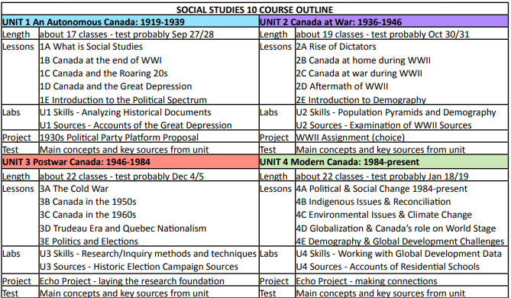

(adapted from G. Thielmann for the Pacific Slope Consortium 2016 pacificslope.ca)

